Assessment and Reporting Policy (Part 1)

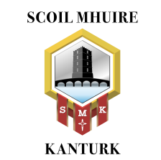

Mission Statement

Scoil Mhuire Kanturk is a Catholic co-educational secondary school under the Trusteeship of CEIST. We are committed to educating our students to their full potential in a spirit of equality and inclusiveness that welcomes and nurtures all of the diverse abilities and talents of the various communities we serve.

Ratified – April 8th 2025

Scoil Mhuire Kanturk - Assessment and Reporting Policy

Context

Scoil Mhuire Kanturk is a mixed second-level school operating within the context of the religious and educational philosophy of the Mercy tradition and the values outlined in the CEIST charter. As a CEIST school, Scoil Mhuire Kanturk is committed to holistic development and to the achievement of the full potential of each student in an atmosphere of care, respect and joy.

Scoil Mhuire Kanturk is committed to ongoing whole school development in collaboration and partnership with the Board of Management, Staff, Parents/Guardians, students and the wider school community.

In accordance with our mission statement, Scoil Mhuire Kanturk is committed to educating our students to their full potential in a spirit of equality and inclusiveness that welcomes and nurtures all of the diverse abilities and talents of the various communities we serve. In the realisation of our mission statement we strive to build community with all partners in education by fostering positive relationships with each other, maintaining professional standards, and by nurturing each student to reach their full potential.

Rationale
The rationale for developing an Assessment Policy is to inform the school community of the position of Scoil Mhuire Kanturk regarding assessment, and to promote uniformity and consistency in our approach to assessment. Scoil Mhuire Kanturk believes that assessment plays a pivotal role in the provision of a meaningful educational experience.
The aim of assessment is to provide a positive and supportive mechanism that helps students to track and improve their learning. Teaching, Learning, Assessment and Reporting (TLAR) are inextricably linked. Students in Scoil Mhuire Kanturk will experience different types of assessment throughout their educational career.
Assessment in Scoil Mhuire Kanturk will be both formal and informal. It will take different formats, reflecting best practice and will be aligned to curricular changes mandated by the Department of Education.

Definitions and Types of Assessment
The term “Assessment” is defined as the gathering and interpretation of information related to a student’s learning abilities, learning attainment, learning strengths and learning needs.
Assessment generates important data and information about how a learner is progressing. This information can be shared with students in the form of feedback that aims to help the learner become more aware of their own strengths and weaknesses, and identify next steps and strategies for improvement.
There are two main types of assessment, firstly Assessment For Learning (AFL) which is formative in nature, involves continuous assessment and occurs during the learning process. Examples include student self-assessments, portfolios and reflections.
Formative assessment involves a range of strategies designed to give students, teachers and parents/guardians’ feedback about students’ understanding of elements of their learning in courses. Formative assessment strategies help students to reflect and identify their strengths, weaknesses and target areas that need work in order to encourage progress. They also help teachers recognise where students are struggling and enable the teacher to develop an intervention to address the problems.
Scoil Mhuire Kanturk supports the Assessment for Learning (AFL) approach to formative assessment. Its purpose is to use the whole process of assessment to help learners improve their learning. It is formative because its intention is to form, shape or guide the next steps in learning.

Assessment for learning:
• Reflects a view of learning in which assessment helps students’ “learning to learn”.
• Involves both teacher and student in a process of continual reflection and review.
• Compliments and underpins on-going planning, and can involve teacher assessment, student self-assessment and student peer-assessment.
• Is criterion-referenced with success criteria based on prescribed learning outcomes identified in the specification/curriculum/syllabus, reflecting performance in relation to a specific learning task. The criteria for success is shared with the learner.
• Involves providing feedback that helps students to recognise what they must do to close any gaps in their knowledge or understanding.
• Supports and guides teachers in adjusting their methodologies in response to assessment outcomes.

Principles of good feedback practice in Assessment for Learning:
Feedback aims to:
• Clarify what good performance is (goals, success criteria, expected standards etc.).
• Facilitate the development of self-assessment in learning.
• Provide high quality information to students about their learning.
• Encourage teacher and peer dialogue around learning.
• Encourage the recognition of student strengths and motivations.
• Promote positive self-esteem.
• Provide opportunities for students to reflect on their learning and to identify gaps between current and desired performance.
• Provides information to teachers that can be used to help shape and guide their teaching.
Classroom Practices and Strategies Supportive of AFL:
• Positive Classroom Culture:
A positive classroom environment, culture and ethos, which encourages students to think and talk about their learning, and which provides a safe and secure place for open, honest and respectful discussion.
• Sharing of Learning Intentions with Students:
Learning Intentions, which will are explicitly shared with students at the beginning of each lesson clarify the goals and places the lesson in its context. The teacher may refer to these learning intentions throughout and at the end of the lesson. This will help to clarify if each student has achieved the desired outcome. This will assist both teachers and students in determining the extent to which the outcomes have been achieved.
• Identifying and Sharing of Success Criteria:
Identifying and sharing the success criteria is used to assess how well the learning outcome has been achieved. Teachers are aware that it is important to share this information with students at the start of an assignment so that they will be in a better position to know what is expected of them. Success criteria, shared with the students in advance, illustrates to students how to recognise success and how their work will be assessed. The students themselves can also use the success criteria to self-assess and re-draft their own work as part of the assessment process. Students may also be encouraged to think about and develop their own success criteria, either individually, in pairs or in small groups.
• Peer Assessment and Self-Assessment:
Self-assessment involves students looking at their own work in a reflective way, identifying aspects of it that are good and that could be improved upon. This facilitates the setting of personal learning targets for themselves. Self-assessment involves metacognition, the process of being aware of and reflecting on one’s own learning, with the aim of improving the quality of thinking and learning occurring. Self-assessment can be used by students of all levels of ability and in all areas of learning. The results of the student’s self-assessment (for example: learning logs, portfolios, pieces of writing) can be shared with their parents/guardians. This can give parents/guardians more information about their student’s learning from the student’s own perspective. Peer assessment empowers students to reflect on and evaluate each other’s work in a purposeful and meaningful way. Both self-assessment and peer assessment are central to encouraging students to become self-directed, independent learners.
• Effective Feedback:
This is essential for students to understand how well they are learning and to identify the next steps in their learning. The teacher is often the person who is best placed to give focused feedback and support to the learner, but the learner can gain important insights into their own learning by reviewing or assessing their own work or by getting feedback from fellow classmates.
Comment-Only Marking (including two stars and wish):
Teachers using their professional judgement, may engage in comment-only feedback, which may include references to what the student has done well, possible areas for improvement and how this improvement might be made.
• Questioning:
Effective questioning serves as a means of deepening the thinking and learning of our students, enabling students to embrace their role in learning as self-directed learners and improving the learning outcomes for our students. Questioning strategies are an important part of developing higher order thinking skills and encouraging students to think systematically and critically, to be creative, to be adaptable and flexible and to encourage them to ask meaningful questions about topics. The implementation of effective questioning strategies has significant positive impacts on student learning experiences
• Reflection:
Reflection is a central component of Assessment for Learning. A focus on reflection can transform student learning experiences into genuine learning opportunities and facilitate the development of deeper awareness. Reflective learning creates and clarifies meaning for the learner and which results in a greater understanding.

Assessment Of Learning

Assessment Of Learning (AOL), which is summative in nature, takes place after the learning has occurred. Summative assessment refers to the assessment of the learning and summarises the development of learners at a particular time. After a period of work, the learner sits a test or completes an assignment which is marked and a score, grade or mark is assigned. Examples include House Exams and State Exams. In Scoil Mhuire Kanturk we strive to combine a balance of both types of assessment to facilitate rich student learning experiences.
Assessment of Learning:
• Is teacher assessment and may be either criterion-referenced (based on Learning Outcomes) or norm-referenced (comparing student achievement to that of others)
• Provides data-based information on student performance that can be shared with students, parents/guardians, and with other members of the school community e.g. school reports
• Can be used to guide judgments about a students’ performance in relation to national standards.
Summative assessments will have a marking scheme developed that:
• Reflects the learning outcomes expected of the learner.
• Is appropriate to the learning outcome level being tested.
• Is planned reliable, valid and authentic.
• Contains a range of questions to test learning outcomes.
• Is based on good assessment practice.
• Provides opportunities for practice for possible questions that occur in state exams.

Summative assessments will take place on a planned and regular basis.
• Class tests are conducted at the discretion of the teacher. Students may have assessments at the end of a topic. This may take the form of a class test or a homework exercise on the entire topic e.g., a past Leaving Certificate question.
• All students are assessed formally. A calendar of assessments for each year group will be published at the start of each school year.
• Mock examinations usually take place at the end of January/start of February. Mock Examination papers are designed externally and corrected externally at a financial cost to students / parents.
• All forms of assessment will strive to meet the additional needs of students in the classroom when they arise. Classroom strategies such as differentiated assessment, visual aids, hearing aids, spelling waivers, increased time and dictionaries etc may be used as appropriate.
Students are expected to treat all of the above forms of assessment with respect. Any student who willingly fails to participate fully, or who acts in a disrespectful way towards any form of assessment in the school, will be dealt with in accordance with other policies such as the Code of Behaviour.
Following formal examinations reports are published on the school MIS (Tyro, Vs ware etc.) and accessible to parents.

Purpose of Assessment
Assessment enables Students:
- To improve their achievement
- To become actively involved in their own learning
- To be motivated to achieve to their full potential
- To become self-directed and autonomous learners
- To engage in reflection and self-assessment
- To develop an awareness of how to look at their own work in a reflective way, identify aspects of it that are good and that could be improved, and then set personal learning targets for themselves.

Assessment enables Teachers:
- To assess progress and adapt planning as required
- To evaluate their pupils’ learning needs
- To ensure that pupils know how to improve the standard of their work
- To evaluate teaching and learning styles and outcomes
- To monitor a student’s progress and to provide the teacher with information to make decisions about what and how the student is learning. This information allows the teacher to identify the next steps in progressing the students learning and adapt his/her teaching strategies and/or learning activities as appropriate.
- To provide the students and parents with information regarding progress
- To establish baseline data in relation to a student’s attainments in certain subjects
- To assess a student’s eligibility for additional support and services and to inform consultations with NEPS Psychologist where necessary.

Assessment enables Parents/Guardians:
- To be involved in their child’s learning
- To understand and encourage the progress their child is making
- To check their child’s progress throughout their time in Scoil Mhuire Kanturk.
- To gain an insight into the broad spectrum of assessments undertaken by students.
- To be informed about their child’s academic progress through school reports and Parent-Teacher meetings.

Junior Cycle Profile of Achievement (JCPA)
Classroom Based Assessments and Assessment Tasks
Formative assessment, complemented by summative assessment, is a key feature of New Junior Cycle. Subject specifications are assessed through two classroom-based assessments (CBAs) - one in second year and one in third year. CBAs allow students to demonstrate their understanding of concepts and skills and their ability to apply them in ways that may not be possible in an externally assessed examination. CBAs are assessed by subject teachers and reported on to students and parents/guardians during Junior Cycle and in the Junior Cycle Profile of Achievement (JCPA). The tasks involved in the CBAs will be specified by the NCCA in consultation with the State Examinations Commission (SEC) on an annual basis.
Subject Learning and Assessment Review (SLAR) meetings are held to support teachers in assessing student CBAs. SLAR meetings are an important part of the assessment process and teachers have received training on the best practices in this area. When assessing the level of student achievement in a Classroom Based Assessment against the learning outcomes, teachers will use ‘on balance’ judgement in relation to the Features of Quality which are set out in four level descriptors as prescribed by the SEC. CBAs will be undertaken by students within class time to a national timetable. Based on national guidelines, Scoil Mhuire Kanturk develops a CBA timetable specific to our students and this is communicated to students and parents annually.

Classroom-Based Assessment Descriptors:
- Exceptional
- Above Expectations
- In Line with Expectations
- Yet to Meet Expectations

Assessment Task
An Assessment Task (marked by the SEC) in each subject will take place. A combination of the Assessment Task and the Final Junior Cycle examination (also marked by the SEC) will generate each student grade for each subject.

Junior Cycle Profile of Achievement (JCPA)
The JCPA will reward and recognise student achievement across all areas of learning, as applicable. Subjects, Short Courses, Wellbeing, Priority Learning Units (PLUs) and Other Areas of Learning. Students will receive their JCPA during the academic year following their Junior Cycle examinations, when all assessment results from the SEC and from school are available and confirmed.
Grading system for Junior Cycle Final Examinations:
- Distinction 85% to 100%
- Higher Merit 70% to 89%
- Merit 55% to 69%
- Achieved 40% to 54%
- Partially Achieved 20% to 39%
- Not Graded 0% to 19%

Examples of the Range of Student Assessment Experiences across the years
First Years
- Homework which may include written, oral, aural, reading, project or portfolio work is assigned regularly.
- Engage in Assessment for Learning (AfL) strategies with the purpose of progressing student learning to the next stage.
- Formative feedback from teachers both verbal and written feedback, which may include comments and/or grades.
- First Years begin to develop the 8 key skills of the Junior Cycle of Achievement e.g. self-assessment to promote the ‘managing myself’ key skill.
- Students may be referred to NEPS for review or assessment if concerns arise from incoming First Year assessment.
- First Year students and parents receive a report via the school’s MIS system (currently Tyro) bi-annually.

Second Years
- Homework which may include written work, oral presentations, research, aural, reading, project or portfolio work is assigned regularly.
- Engage in Assessment for Learning (AfL) strategies with the purpose of progressing student learning to the next stage.
- Formative feedback from teachers both verbal and written feedback including comments and/or grades.
- Second Years continue to develop the 8 key skills of the Junior Cycle of Achievement.
- Second Years complete the first classroom-based assessment (CBA). The criteria for assessment are found in the features of quality linked to each Classroom-Based Assessment.
- Second Year students and parents receive a report via the school’s MIS system (currently Tyro) bi-annually.
- Reporting on CBA’s.

Third Years
- Homework which may include written work, oral presentations, research, aural, reading, project or portfolio work is assigned regularly.
- Engage in Assessment for Learning (AfL) strategies with the purpose of progressing student learning to the next stage.
- Formative feedback from teachers both verbal and written feedback including comments and/or grades.
- Third Years continue to develop the 8 key skills of the Junior Cycle of Achievement
- Additional individual testing, using tests such as WRAT4/5 or WIAT III are completed to support RACE applications, where required
- Third Year students complete the practical components in certain subject areas.
- Third Year students undertaking their second CBA.
- Third Year students complete an Assessment Task following CBA 2. The Assessment Task is a written task completed by students during class time, which is not marked by the class teacher, but is sent to the State Examinations Commission for marking. The Assessment Task is specified by the NCCA and is related to the learning outcomes on which the second Classroom-Based Assessment is based.
- Third Year students and parents receive reports via the school’s MIS system (currently Tyro) after completing their House and Mock Examinations.
- Reporting on CBA’s
- Progress Reports.
Transition Year
- Rich learning experiences and personal development are the hallmarks of the Transition Year Programme in Scoil Mhuire Kanturk.
- Participation in TY events and activities is continuously assessed
- Engage in Assessment for Learning (AfL) strategies with the purpose of progressing student learning to the next stage, promoting personal growth, developing self-confidence, discovery learning and embracing leadership and learning.
- Focus on portfolio assessments, reflective journaling, e-portfolios, oral presentation as well as self and peer assessments.
- CAT4 Testing
- TY students compile their reflection portfolios to articulate their personal learning milestones, examples include Outdoor Pursuits Trip, Young Scientist, Work Experience, Mini-company, Gaisce and many more.
- Homework which may take the form of written work, oral presentations, research, aural, reading, project or portfolio work is assigned regularly.
- Transition Years and their parents/guardians receive an overview of the students’ rich learning experiences at the TY Parent Evening and the plethora of learning experiences is celebrated at the TY Graduation in May.
- TY students and parents receive a report via the school’s MIS system (currently Tyro) bi-annually.

Fifth Year
- Homework which may take the form of written work, oral presentations, research, aural, reading, project or portfolio work is assigned regularly.
- Engage in Assessment for Learning (AfL) strategies with the purpose of progressing student learning to the next stage.
- Formative feedback from teachers both verbal and written feedback including comments and/or grades.
- Project work, oral and aural work for Leaving Certificate subjects
- Referrals to NEPS for review or assessment if required
- Individual additional testing, such as WRAT-IV / V and WIAT III for RACE applications where required
- House Examinations
- Fifth Year students and parents receive a report via the school’s MIS system (currently VSWARE) bi-annually.
- Progress reports.

Sixth Year
- Homework which may take the form of written work, oral presentations, research, aural, reading, project or portfolio work is assigned regularly.
- Engage in Assessment for Learning (AfL) strategies with the purpose of progressing student learning to the next stage.
- Formative feedback from teachers both verbal and written feedback including comments and/or grades.
- Sixth year students engage in a range of formal and informal assessments. The Mock Examinations are in February. The Leaving Certificate State Exams are in June.
- Project or practical course work for Leaving Certificate subjects.
- Preparation for and completion of the oral component of Irish or French.
- House Examinations
- Sixth Year students and parents receive a report via the school’s MIS system (currently Tyro) bi-annually.
- Progress reports.
The CAO Common Points Scale
Full details of the mechanics of the CAO application and offer process can be found on the CAO website. Applicants must meet the minimum entry requirements, and places on courses will be awarded based on the applicant’s position in the order of merit list, where the applicant with the highest points is at the top of the list. 25 bonus points will continue to be awarded for Higher Level Mathematics for grade H6 and above.
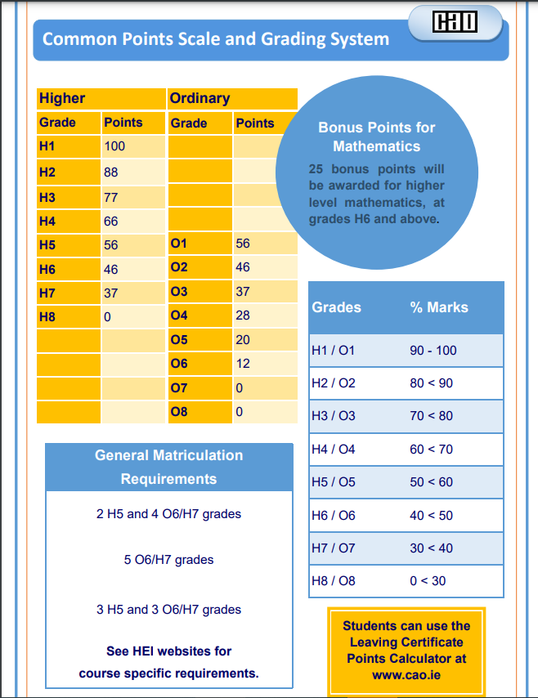
Annual Analysis of State Examinations Results
Once the SEC issue the results for Leaving Certificate and Junior Cycle examinations, each subject department in Scoil Mhuire Kanturk conducts an analysis of their subject results and compares them to the national averages. Athena tracker is used to support subject departments in this work. Departments examine trends that may emerge in their subject results over a number of years. This process is led by the Academic Tracking Manager and Senior Management Team. Subject department reflections and future plans are discussed and noted. The overall statistics and data in relation to school state examination results are recorded for School Self-evaluation purposes and are communicated to the Board of Management.

Links with other policies
This policy should be read in conjunction with the Assessment Instruments Policy. Other links include:
- Homework Policy
- Inclusion Policy
- Code of Behaviour
- Assessment Policy (Part 2)

Review and ratification of policy.
This policy was ratified by the Board of Management of Scoil Mhuire Kanturk on April 8th 2025
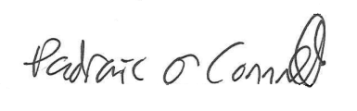
Signed by: ______________________________ Chairperson
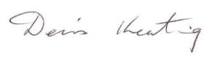
______________________________ Principal

Review date: April 2027

