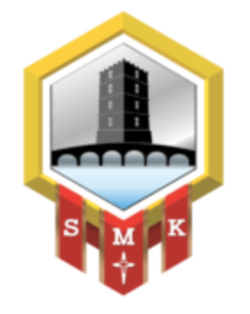
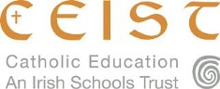
The Board of Management of
Scoil Mhuire Kanturk, Co. Cork
invites applications for the post of
Deputy Principal

To take effect from November 3rd, 2025
Scoil Mhuire is a Co-Educational Catholic Secondary School (Current Enrolment 299) under the trusteeship of CEIST and is conducted in accordance with CEIST Charter Values.
The application form and further documentation can be obtained from
https://www.scoilmhuirekanturk.ie/
Emails with completed application forms will be accepted up to
Wednesday August 20th, 2025 at 10 am

Short-listing may apply.

The Board of Management is an equal opportunity employer

Provisional Date for interviews is
Week beginning August 25th, 2025.

This appointment is subject to sanction by the Department of Education

